Jira Assignment - 5

Screenshot # 1 – Create at least 2 releases for your project.

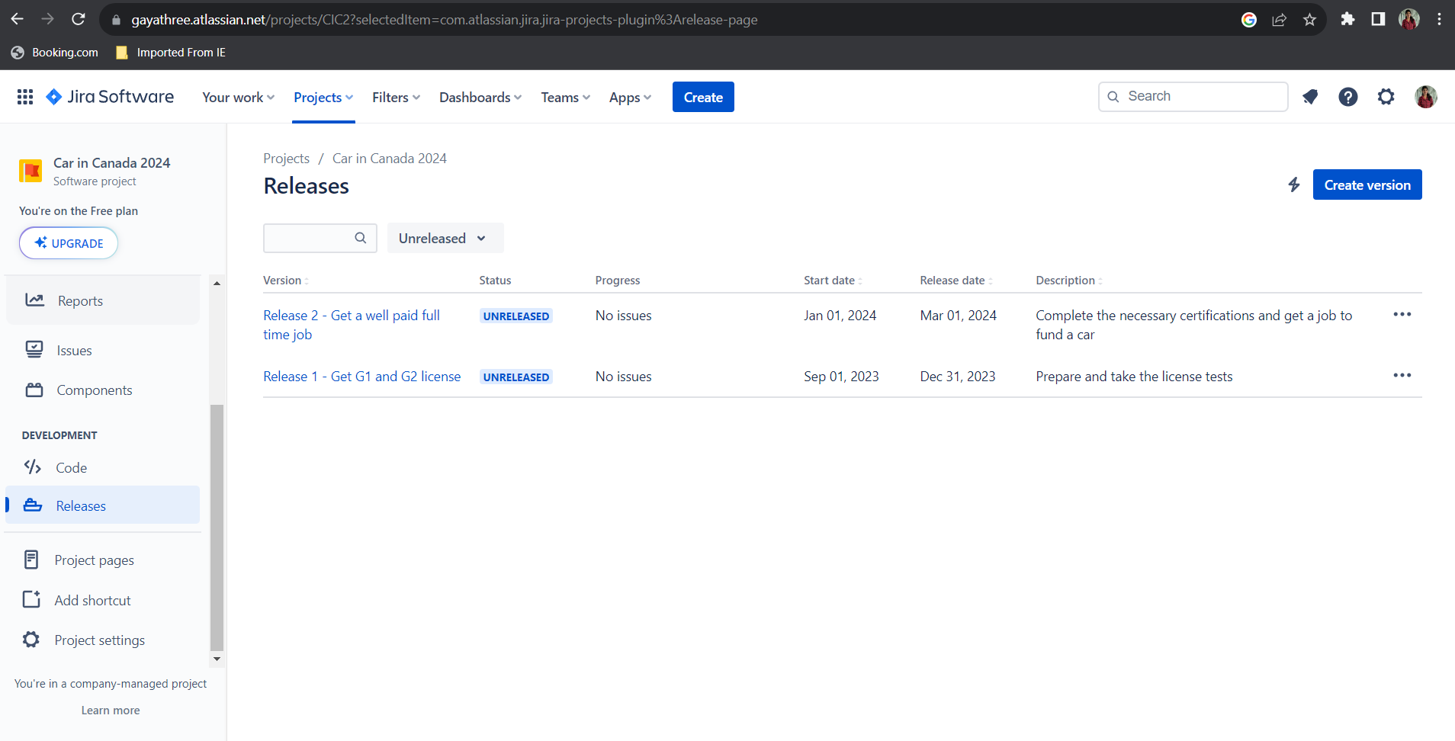

Screenshot # 2 – Create at least 2 epics that make sense for your project. Give names and descriptions for both. Then add the stories from your  
backlog that belong to those epics.

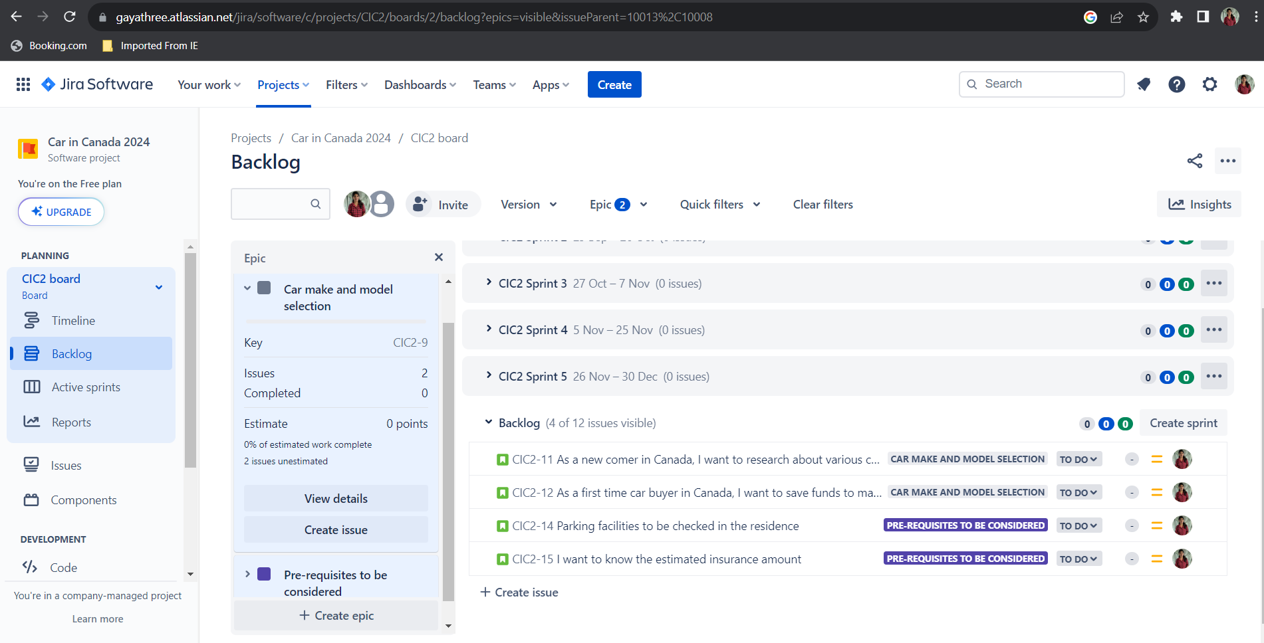

Screenshot # 3 – Create a sprint, add stories to the sprint

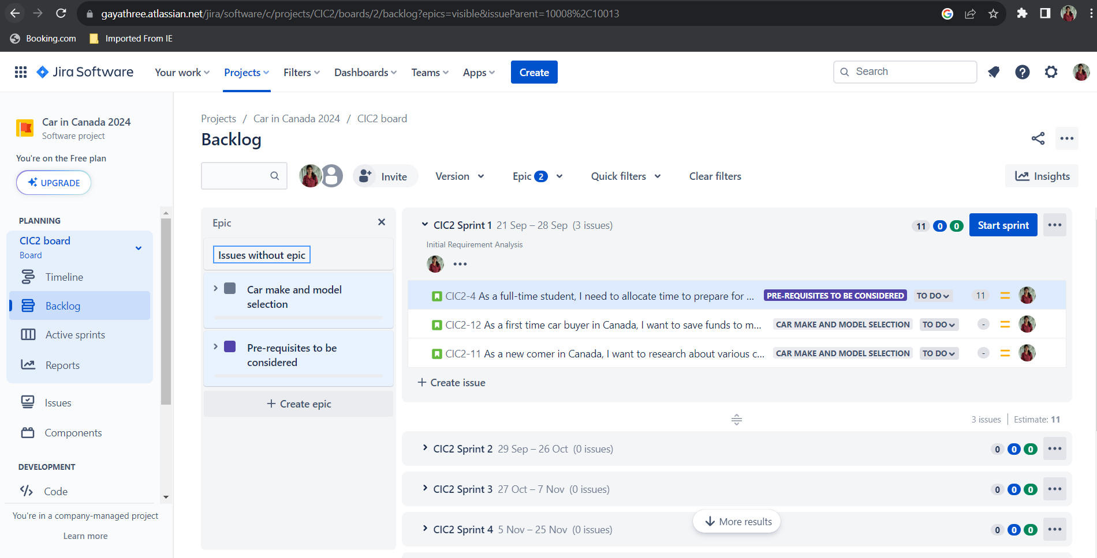

Screenshot # 4 – Add at least 3 sub-tasks to one of your stories in your sprint.



Screenshot # 5 – All user stories written in correct format discussed in class.

